Part 3, DB Mapping

Relational Database Definitions

* **Table or Entity** 🡺 A collection of records.
* **Attribute or Column or Field** 🡺 A characteristic of an entity.
* **Row or Record or Tuble** 🡺 the specific characteristics of one entity.
* **Database** 🡺 A collection of tables.

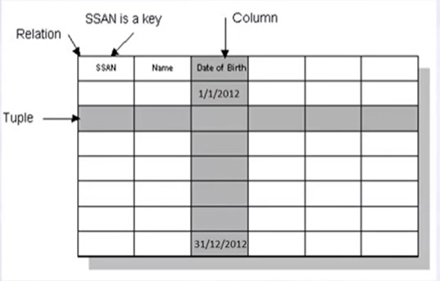

Mapping 🡺 DB Schema

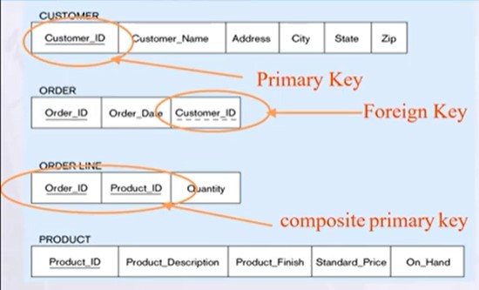

ER – to – Relational Mapping

Step 1 🡺 Mapping of Regular Entity Types.

Step 2 🡺 Mapping of Weak Entity Types.

Step 3 🡺 Mapping of Binary 1:1 Relation Types.

Step 4 🡺 Mapping of Binary 1:N Relationship Types.

Step 5 🡺 Mapping of Binary M:N Relationship Types.

Step 6 🡺 Mapping of N-ary Relationship Types.

Step 7 🡺 Mapping of Unary Relationship.

Step 1 🡺 Mapping of Regular Entity Types

* Create table for each entity type.
* Choose one of key attributes to be the primary key.

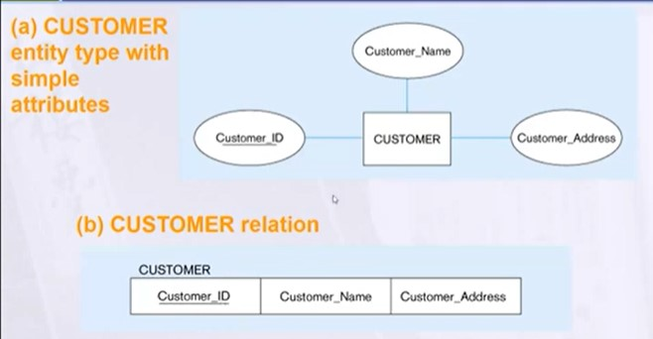**Mapping Regular Entity**

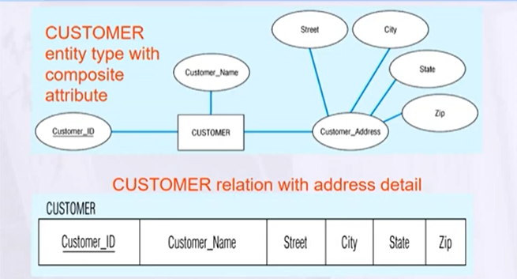**Mapping Composite Attribute**

**Mapping Multivalued Attribute**

**Mapping Complex Attribute**

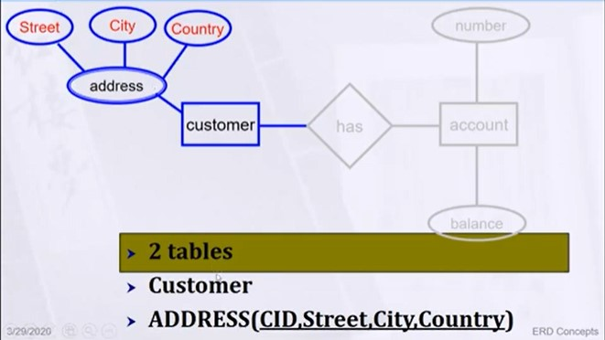

Mapping Derived & Complex

* In the most cases Derived attribute not be stored in DB.
* Mapping Complex like Mapping Multivalued attribute then including parts of the multivalued attributes as columns in DB.

Step 2 🡺 Mapping of Weak Entity Types

* Create table for each weak entity.
* Add foreign key that correspond to the owner entity type.
* Primary key composed of:
  + Partial identifier of weak entity.
  + Primary key of identifying relation (strong entity).

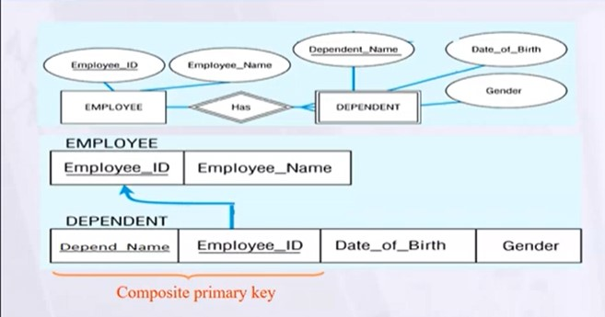

Step 3, 4 🡺 Mapping of Binary Relationship Types (1:1 and 1:N)

One – to – One Relationships



One – to – Many Relationships



Step 5 🡺 Mapping of Binary M:N Relationship Types

* Create a new third table.
* Add FKs to the new table for both parent tables.
* Add simple attributes of relationship to the new table.

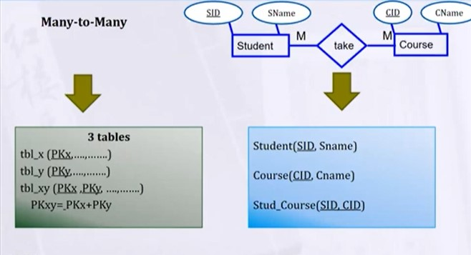

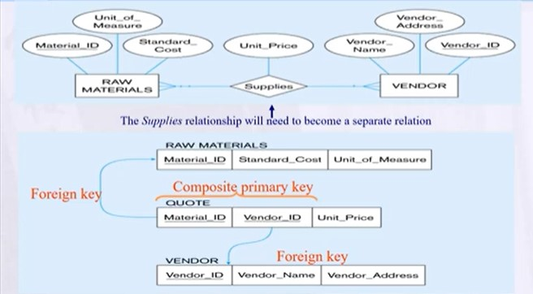

Step 6 🡺 Mapping of N-ary Relationship Types

* If n > 2 then:
  + Create a new third table.
  + Add FKs to the new table for all parent tables.

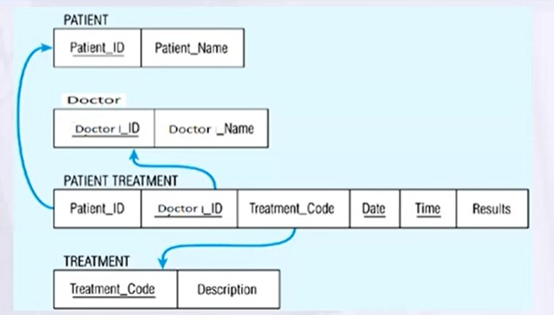

Step 7 🡺 Mapping Unary Relationship

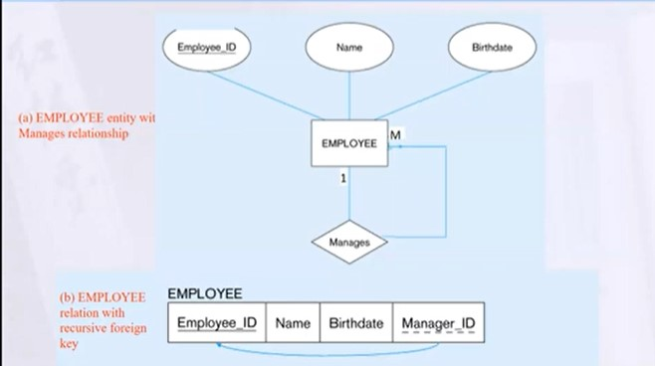

Case Study

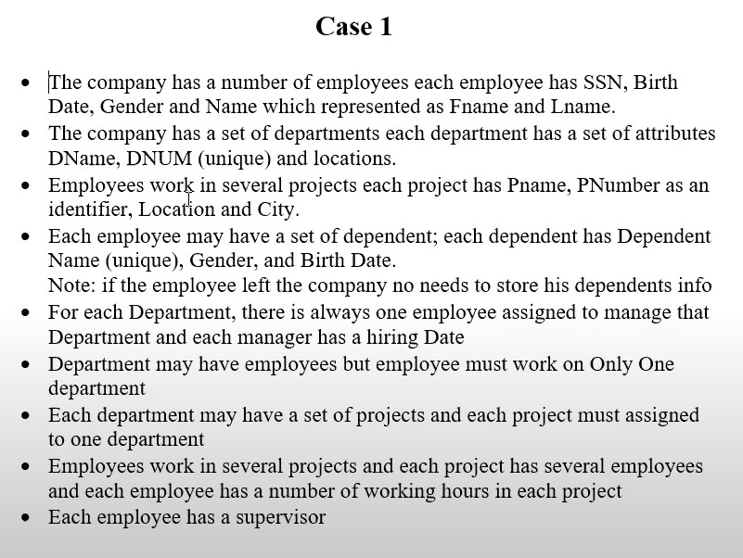

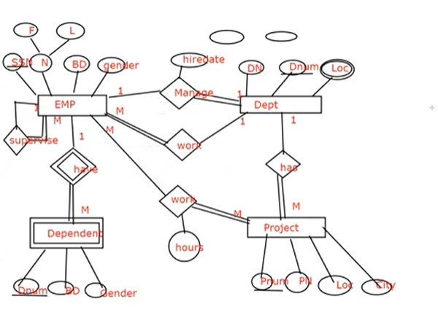ER – Diagram

Mapping of the Case

